Kirin Harrington

kirin@twosmallpeople.co.uk

Abstract

[Draw your reader in with an engaging abstract. It is typically a short summary of the document.   
When you’re ready to add your content, just click here and start typing.]

UNIT 4

Kirin H

Contents

Jobs in interactive media production 3

Technical security consultant 3

Good understanding of network/cloud security 4

comercial experience with siem tools 4

working knowledge of zscalar and azure sentinel 4

proven ability to liaise with and manage senior stakeholders realting to technical matters 4

good understanding and awareness of ITIL/service management 4

Security engineer 4

Extensive knowledge of windows, linux/unix, network 5

knowledge of firewall, IDS, data encryption, dlp 5

very strong understanding of AWS platform 5

strong understanding of active directory, dns, ldap and okta 5

good communication skills 5

Senior Cyber security engineer 6

ITIL and/or six sigma certified 6

Cisco CCNA, CCNP or equivalent industry experience 6

Ports, SSL/TLS, IPS/IDS, VPN, MPLS 6

strong knowledge of security principles and network concepts 6

working knowledge of security domains, auditing standards, frameworks, and risk analysis frameworks 6

Cyber security and risk advisor 7

Holds or interested in gaining relevant certifications (CISSP, CISA, CRISC or equivalents) 7

Strong integrity, independence, and resilience 7

Demonstrable experience of information security within a specific information risk and assessment/audit capacity 7

excellent communication skills, both written and verbal 7

A good team player, with the ability to act independently and exercise sound judgement 7

Mobile application developer 8

Skills of building well-implemented native Android and iOS apps 8

Up to date knowledge of android SDK and Apples APIs 8

Swift/Java and Kotlin experience 8

Good understanding of unit and automated testing 8

Strong familiarity with android studio and XCode 8

Permeant vs freelance 9

Presentation Methods 9

Presenting interactive media products 10

Jobs and presentation methods 11

Mobile application developer 11

Technical security consultant 11

Cyber security and risk advisor 12

Security engineer 12

Senior Cyber security engineer 12

Types of CLIENTS 12

BRIEF 12

Presentation 12

BRIEF 12

Presentation 13

BRIEF 13

Presentation 13

BRIEF 13

Presentation 13

BRIEF 13

Presentation 13

Promoting skills 14

Paper CV 14

Benefits 14

Limitations 14

Description 14

Exhibition 14

Benefits 14

Limitations 14

Description 15

Portfolio website 15

Benefits 15

Limitations 15

Description 15

Social media presence 15

Benefits 15

Limitations 16

Description 16

Selection of format 17

Presentation method and features 17

benefits and limitations of this method 17

Benefits 17

Limitations 17

Overview 17

Software 18

Software used: Microsoft powerpoint 18

benefits 18

Limitations 18

Other software 18

Effect of software 18

Strengths and weakness 19

Strengths 19

Large amount of evidence 19

Effective use of whitespace 19

user-friendly and easy to navigate 19

Weaknesses 19

Lack of videos 19

Not enough information 19

Doesn’t provide a full picture of the project 19

Areas for improvement 19

# Jobs in interactive media production

## Technical security consultant

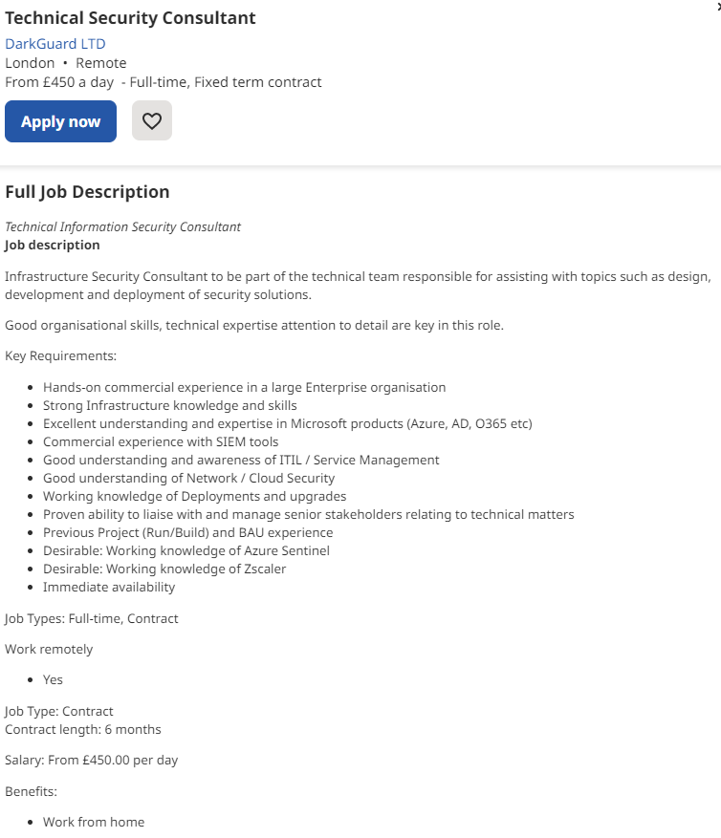

### Good understanding of network/cloud security

This means the applicant must have a strong understanding of network/cloud security, this is because it is frequently used in this job and is a key part of the role.

### comercial experience with siem tools

The applicant must have experience with using SIEM tools in a commercial environment

### working knowledge of zscalar and azure sentinel

The applicant must know how to practically use zscalar and azure sentinel, their knowledge must also be recent, allowing them to work with the latest updates.

### proven ability to liaise with and manage senior stakeholders realting to technical matters

The applicant must have experience with communicating with senior stakeholders in relation to technical matters and will probably need to provide a reference to prove this.

### good understanding and awareness of ITIL/service management

This means the applicant must be aware of how ITIL/service management works and understand how to use it in relation to their job.

## Security engineer

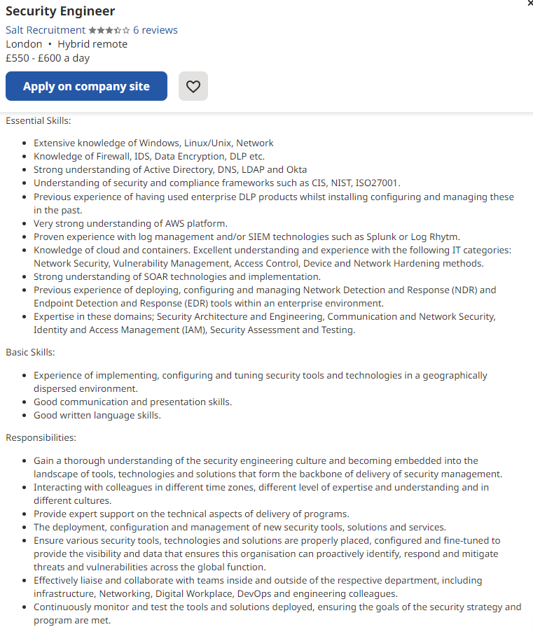

### Extensive knowledge of windows, linux/unix, network

This requires the applicant to have a large amount of knowledge about windows Linux/Unix networks

### knowledge of firewall, IDS, data encryption, dlp

The applicant must understand how firewalls, IDS, data encryption and dlp works, in order to use them in their day-to-day job

### very strong understanding of AWS platform

This means the applicant must know a large amount about the AWS platform and be able to use it confidently

### strong understanding of active directory, dns, ldap and okta

The applicant must have a very strong knowledge of how active directory, dns, ldap and okta work

### good communication skills

This is a basic skill which means the applicant must know and be able to communicate well with their colleagues

## Senior Cyber security engineer

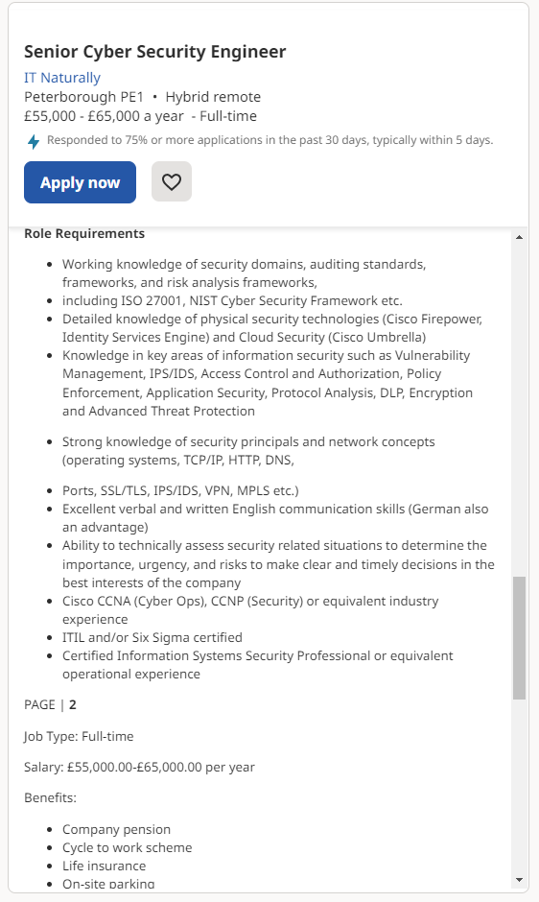

### ITIL and/or six sigma certified

This requires the applicant to have completed a course in ITIL and/or six sigma, and be able to provide proof of this

### Cisco CCNA, CCNP or equivalent industry experience

The applicant must have experience working with Cisco, CCNA, CCNP in an industry setting

### Ports, SSL/TLS, IPS/IDS, VPN, MPLS

This requires the applicant to have knowledge of ports, and be able to use them

### strong knowledge of security principles and network concepts

The applicant must have strong knowledge of security principles and network concepts

### working knowledge of security domains, auditing standards, frameworks, and risk analysis frameworks

The applicant must have current and up to date knowledge of security domains, auditing standards, frameworks and risk analysis frameworks

## Cyber security and risk advisor

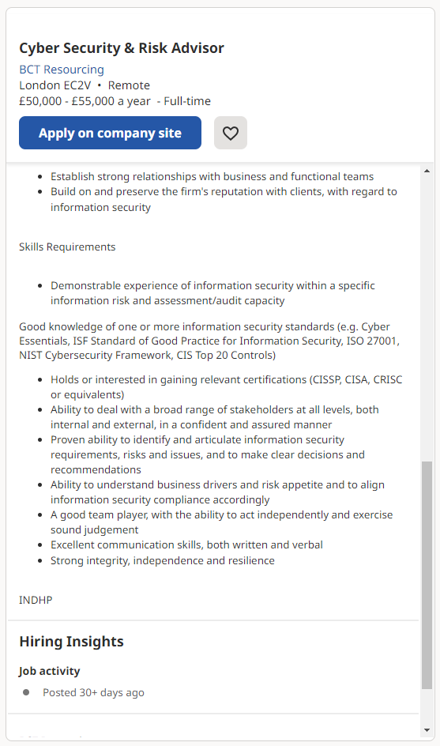

### Holds or interested in gaining relevant certifications (CISSP, CISA, CRISC or equivalents)

This requires the applicant to already have CISSP, CISA, CRISC certifications, or be interested in gaining them

### Strong integrity, independence, and resilience

These are basic skills relating to the applicant’s personality, requiring them to be able to work independently, be able to persevere, and have strong integrity

### Demonstrable experience of information security within a specific information risk and assessment/audit capacity

The applicant must be able to show that they have experience of information security within a specific information risk and assessment/audit capacity

### excellent communication skills, both written and verbal

This is a very basic skill, it means that the applicant must be able to communicate well, both in their writing, and through speaking to colleagues.

### A good team player, with the ability to act independently and exercise sound judgement

The applicant must be able to work well within a team, but also be able to work independently and make their own decisions

## Mobile application developer

.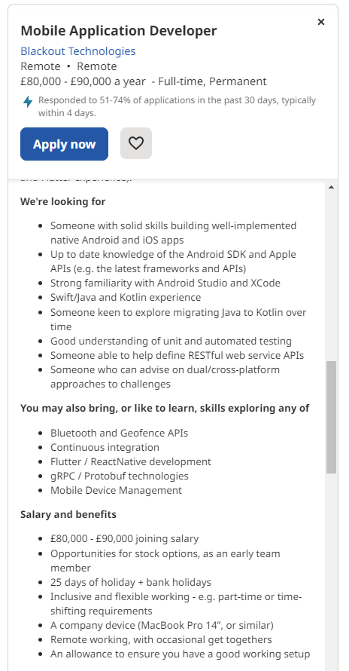

### Skills of building well-implemented native Android and iOS apps

The applicant must have skills on how to build well-implemented native android or iOS apps

### Up to date knowledge of android SDK and Apples APIs

The applicant needs to have current and relevant knowledge of how the android SDK and Apple APIs work

### Swift/Java and Kotlin experience

This means that the applicant needs to be knowledgeable about how swift/java and Kotlin work, and need to have experience using them

### Good understanding of unit and automated testing

The applicant needs to have a good understanding of unit and automated testing and be able to use both fluently

### Strong familiarity with android studio and XCode

This means the applicant must be familiar with using android studio and XCode, and be able to use them well

# Permeant vs freelance

Freelancers are hired for a temporary period, usually to complete one job, and leave when it’s done. A permeant role is long term role where you have a set role in the organization and will do for the foreseeable future

|  |  |  |
| --- | --- | --- |
|  | Pros | Cons |
| Freelance | * Have higher flexibility about where you work which allows you more freedom with your life, allowing you to choose which company you work for, based on earnings or ethics. * Have higher flexibility about where you live as you can travel and move around a lot more, which means you can choose which city you’d like to work in and have the freedom to move if you wish * They have a much higher earning potential, this is because you can look around for the highest paying jobs and can start at a high pay grade, rather than having to work your way up through the company | * Requires a lot more work as you need to submit your own records and manage everything yourself, which would require you to have a lot more skills * There is no guarantee that you will have a client, and therefore income so it can be a lot riskier * You cannot always plan your life as you may have to take a client when they come around meaning plans may have to be cancelled in the line of work |
| Permanent | * Jobs are more permanent, which means that you don’t have to stress about having a reliable source of income or finding new clients to work for * Reliable income for the foreseeable future, allows more job security in the scenario of some catastrophic event happening, and allowing you to plan your future with a consistent stream of income in mind * Companies are more likely to hire permanent employees because then they have that asset for a long time rather than having to find new people frequently | * You are confined to one job, potentially for a long time, which allows you less freedom with how you live your life * Have lower earning potential, often forcing you to spend years working up through different pay grade, only to reach a lower wage overall * You have less flexibility about where you can live and times when you work, meaning that it would be harder to spend time with friends/family and do activities that you find enjoyable |

# Presentation Methods

|  |  |
| --- | --- |
| **Reason to present** | **Information about reason** |
| Interviews | This could be used to show off an example of a product you have made or projects you have worked on to a potential employer |
| To win contracts | A company may be showing off their existing product or work they have done in an attempt to gain clients |
| Growing awareness | To raise awareness, you could organize an event to show off your interactive product or book a place in an existing event. |
| Presenting a prototype | This could be presented to potential investors or customers, or to a group of people to receive suggestions to help the final project to be as good as possible |
| Pitching a project | If you have an idea for a product and are attempting to find funding or a client |

# Presenting interactive media products

There are many reasons why people would need to present an interactive media product, as an individual you may want to present a product or skills you have to an employer in an interview, you also may be wanting to gain funding for a project, and this could involve meeting with some potential investors so you can present your project to try and secure funding. If you are part of a company you may want to present past work you have done or services you provide to attempt to gain new customers, you could do this through a leaflet or a letter, on social media, or even at a public event. You may also be trying to improve your project, presenting it to a group of people to gain feedback to help improve the final version could be very beneficial. You could also be trying to gain awareness about your company and raise its profile, you could do this through a public event or some sort of advert.

|  |  |  |  |
| --- | --- | --- | --- |
| Type of presentation | Benefits | Limitations | Potential Clients |
| Digital Portfolio – For printing, for example a CV | -Can be handed, printed or sent to clients -Relatively cheap to produce -Can showcase text and images | -Could result in using a lot of paper to print out a lot of copies  -Cannot be updated after it has been printed or sent  -Cannot showcase audio or video | Would be very useful for an employer who frequently visits events and can therefore be handed the printed CV, it’s also useful for someone who does not use the internet as much as it is a physical copy. |
| Digital Portfolio – Not for printing | -Can be updated easily -Can be easily emailed to clients  -Can showcase all kinds of media, text, image, audio and video | -Could result in a very large file size  -Could take a long time to create  -Easy for a client to miss an email | Useful for someone who frequently uses the internet and doesn’t travel to events as often as it can be sent to them and they can view it in their own time. |
| Promotional video | -Can be easily distributed or placed online  -Can showcase all kinds of media, text, image, audio and video  -Very entertaining and more interesting than a text document for clients to read | -Could be very expensive to produce  -Could result in a very large file size  -Very difficult to update | Useful for someone who is busy and therefore doesn’t have much time to look through documents and therefore a short video is easier. |
| Social media/Viral marketing | -Can be easily distributed online  -Can be accessed freely by a large group and range of people  -Can be easily changed and updated | -Could be difficult to create  -Harder to send to specific clients  -usually short in length so it’s harder to convey more information | Useful for someone who frequently uses social media and doesn’t have much time as they usually consist of shorter content. |
| Slideshow presentation | -Can be viewed by a large group of people on a projector or large screen at the same time  -Relatively easy to distribute and send to potential clients  -Easy and cheap to produce | -Could be long and seem uninteresting to clients  -Not all clients will be able to open the file as they may not have the applications to do so  -Could result in a large file size | Useful for someone who visits in person events as this can be presented to them in person. |
| Interactive showcase | -Can be viewed by a large group of people at the same time  -Encourages user interaction  -Can show all kinds of media, text, images, audio and video | -Could take a very long time to produce  -Very difficult to update  -Could result in a very large file size | Useful for someone who enjoys experiencing a project. |

# Jobs and presentation methods

### Mobile application developer

#### Interactive presentation

An interactive presentation would work best in this situation as it would allow the employers to use and interact with applications they have made in the past, which would let them showcase their skills and past experiences, as well as allowing for them to show off features or elements to potential employers.

### Technical security consultant

#### Digital portfolio

A technical security consultant could use a digital portfolio as it allows for images to be contained as well as text which could contain references from previous employers and examples of work they have previously made, along with their skills and qualifications

### Cyber security and risk advisor

#### Digital portfolio

A cyber security and risk advisor would also use as digital portfolio as it can be sent online to different employers or printed and handed to employers in person, it can contain images and text to showcase their work and links to their previous employers or courses/qualifications they have completed

### Security engineer

#### Slideshow presentation

A security engineer could use a slideshow presentation as it can contain videos and images which showcase their work and can let potential employers navigate through different pages and view their work, it would also allow for an in person or virtual presentation which would allow the audience to ask questions or comment on things.

### Senior Cyber security engineer

#### Promotional video

A senior cyber security engineer could use a promotional video as it could showcase a compilation of the work they have done in the past, a voice over to explain what is happening in the video alongside interviews and comments from previous employers which could reveal their positive traits, this also has the advantage of being sent virtually.

# Types of CLIENTS

## BRIEF

A PC building website aimed at university students.

### Presentation

A slideshow presentation could be used to present your website and features that is has to a large group of students, this could be presented in a lecture theater or in any room with the facilities to present your slideshow

#### Justification of methods

A slideshow presentation would allow them to showcase different parts or features of the website and key information from the website, it could also include a video demonstration of the website in action, alongside this it could be presented to people in person or sent online and is therefore very versatile.

## BRIEF

An interactive display showing facts about a local bookstore.

### Presentation

Slideshow presentation, this could be presented in the bookshop on a tablet style device or a touchscreen tv, to allow all customers to use it freely

#### Justification of methods

The slideshow presentation could show different features and how different parts of the interactive bookstore display, it could also show a video of someone using the display alongside a voiceover explaining it, it could be sent to potential employers online or presented in person

## BRIEF

An educational 2D side-scrolling game for Primary school students.

### Presentation

Promotional video, this could be sent to the school for teachers to play in class, or posted online for parents and students to view

#### Justification of methods

A promotional video would be the best way to present the education 2D side-scrolling game as it could include clips of people playing the game, alongside reviews from people who have played it before and even a voiceover.

## BRIEF

A blog-website showcasing recipes.

### Presentation

Social media/viral marketing would be seen by a wide range of people online and could also be sent to potential employers specifically

#### Justification of methods

Social media would be the best way to present your blog-website as you could post images or short videos with captions and quickly gain awareness online from a massive range of people, it could be a very quick way to gain a large user base due because as it gains popularity more and more people view it.

## BRIEF

An app for explaining the basics of playing chess.

### Presentation

Interactive showcase, could be showcased at an event focused on chess or in a shop related to chess, for anyone who’s in there to view

#### Justification of methods

An interactive showcase would be the best way to showcase an app for explaining the basics of playing chess, as it could contain a demonstration, allowing the audience to try it out themselves.

# Promoting skills

## Paper CV

### Benefits

Paper CVs have the advantage of allowing you to hand them to employers in person, meaning they will be less easy to be forgotten as they will have a physical copy and will mean that you’re more memorable. They’re also very cheap to produce a large number of them, meaning that handing them to people in person will not be too expensive, they’re also a quick and concise way to present your skills, allowing your client to learn a large amount about you very quickly

### Limitations

However, Paper CVs cannot be sent digitally, meaning that you have to actually be with the employer for them to receive your CV, they also cannot be updated once printed, meaning if you gain more experience or wish to change your CV based on your employer, you will have to re-print them and the old CVs may become useless, it is also easy for the employer to lose them, as physical things can be easily misplaced and lost, with no records of your CV

### Description

A typed and printed out document which can be given to potential employers containing information about the applicant and their skills alongside the applicant’s previous experience, projects, past jobs and their qualifications, it is generally condensed down to about the size of about two pages, to not put the employer off reading it.

## Exhibition

### Benefits

An exhibition can create a very memorable and professional event, meaning that your client is a lot more likely to remember you and it can create a very good impression on them, they also allow the audience to interact with various elements and browse the work that you have done, meaning they can spend as long or as little time on each individual element, it also allows you to interact with multiple employers at once, as they walk around meaning you can spread word about yourself a lot faster

### Limitations

An exhibition also has some downsides, as they require the employer to physically come to your experience, so it will only work for employers in a certain area as others may not be prepared to travel as far, they also cannot be viewed or used again after the experience is over, meaning that if the client wishes to have a look at your skills and experience again they are unable to, and they can also be very difficult and expensive to set up, requiring a lot of time and money many people may not be prepared to spend

### Description

An in-person display containing a large number of projects or skills the applicant has worked on, this is usually set out in a way that allows the employer to browse different parts and browse the applicants work, it’s a very impressive and memorable presentation.

## Portfolio website

### Benefits

A portfolio website has the advantage of being able to be updated at any time, meaning that as your skills and experience increases, so can your website, they’re also easily viewable at all time for employers, meaning that they can review your skills at any time, they also mean that you can showcase multiple different projects and skills, and the employer can pick and choose which parts they view and are interested in

### Limitations

A portfolio website, however, cannot be personalized based on the company who is viewing the website, meaning that they may see information which isn’t relevant to the skills they’re looking for, the website can also be difficult or time consuming to set up, requiring a lot of effort or skills, and can be difficult to navigate or take key information out, meaning that the employer may have a hard time dissecting your website to find the information relevant to them

### Description

A website which showcases different projects, skills or qualifications the applicant has worked on or obtained, this can be made by the applicant or by using a website builder, this website contains information which is personal to the applicant and can be updated at any time, however the information should be generalized and also categorized as multiple different employers will view the website that may not want to read it all.

## Social media presence

### Benefits

An advantage of a social media presence is that they can easily be shared and viewed by a great number of people, meaning it is easy to reach a great number of people, they also can contain video, text and images showing the work the applicant has created, allowing for a multitude of interesting ways to showcase your work, and can be easily added to at any time, meaning that as your skills increase you can post more images/videos of your skills for potential employers to view

### Limitations

However, due to the vast amount of content on social media, it would be easy for the potential employer to miss or forget your specific content, posts are also usually short so they might not be able to showcase much work, meaning that the employer would have to look through multiple of your posts, which is very time consuming, social media networks are often seen as less professional so may not be seen by some employers, especially older ones which may not have embraced social media

### Description

This involves using various social media networks and platforms to share work and skills the applicant has, and projects they have worked on, through a series of messages and videos which can be easily spread and seen by a great many people.

LO3

# Selection of format

## Presentation method and features

I used PowerPoint as my method of presentation, this is because it allows you to easily create and organize slides with a variety of media, such as text and images, and allows you to add animations, transitions, notes and other useful elements to enhance the presentation. This allowed me to present my project in a clear and comprehensive way, in addition to this PowerPoint can be easily shared and viewed on a variety of devices, which means it’s very convenient for both in-person and remote presentations.

I used Images to clearly show parts of my project and give the audience a clear idea of what the elements of my project look like. Notes to add extra useful information which would be helpful to talk about when presenting without filling up the PowerPoint slides with too much information which could make them seem daunting. Animations to give the PowerPoint a professional feel and help the slides fit better together and feel less choppy, and overall enhance the user’s experience.

I didn’t use animations; this would have been useful to give the user a more immersive experience as they would have been able to see things moving, I also didn’t use videos, which would have been beneficial because the user could have seen the project in action which could have been helpful.

## benefits and limitations of this method

### Benefits

#### QUICK AND EASY TO CREATE

PowerPoints are relatively quick and easy to create, and allow the user to choose from a variety of templates to quickly achieve a professional looking presentation

#### USEFUL AND COMPREHENSIVE SET OF TOOLS

PowerPoints provide a powerful set of useful and comprehensive set of tools which allow you to increase the quality of the presentation, allowing users with less experience to still create high quality and professional PowerPoints

#### EASY TO USE AND WORKS ON A LARGE VARIETY OF DEVICES

PowerPoints work on a large number of operating systems such as Windows and Mac to create and edit PowerPoints which can then be shared and used on a large variety of devices.

### LIMITATIONS

#### POTENTIAL FOR DISTRACTION

PowerPoints include the potential for distraction if the presentation is full of too many visual elements, which could cause the user to become distracted or overwhelmed and ultimately less engaged in your presentation.

#### PRESENTERS SKILL

PowerPoints also rely heavily on the presenter being able to present it in an engaging and interesting way and having the knowledge to present the topic, alongside involving the audience in the presentation so that

#### Requires in-person presentation

PowerPoints presentations are a lot more successful when presented in person, which requires all of the clients being in one place at the same time, which could be difficult if there is a large geographical area between them

### Overview

Picking the right presentation technique is very important as it could cause the client to become disinterested and therefore think of your project in a less positive light, an engaging and interesting presentation is essential as it needs to be able to show off the elements of your project in a comprehensive way so that it all makes sense.

For the purpose of presenting my project a PowerPoint was very effective, as it is a quick and professional way of presenting a large amount of information, it allows for it to be presented in-person or online, as well as just being viewed by the recipient.

# Software

## Software used: Microsoft powerpoint

### benefits

PowerPoint is very user-friendly and easy to navigate, which makes it a very good option even for people with little to no design experience

PowerPoint contains built-in templates which users can use to customize and create professional looking presentations

PowerPoint allows the user to easily incorporate forms of media such as images and audio in their presentations to enhance the experience of the user and relay information easier

PowerPoint works across many platforms such as Windows and Mac operating systems and can be easily shared, presented and edited by many people.

### Limitations

PowerPoint contains many design options, but it still has some limitations compared to some other more advanced design software.

PowerPoint has limited animation options resulting it in being difficult to create complex and smooth animations

PowerPoint presentations often rely heavily on text, which can quickly get out of control and result in large blocks of text which are not engaging for the audience

PowerPoint has many visual features which can easily get overused and result in a overwhelming experience for the audience

## Other software I used

### Snipping tool

I used “Snipping tool” throughout the creation of my project to take screenshots of specific parts of my screen to use as evidence in my presentation, this tool was very easy to use and simple, and allowed for quick screenshots which didn’t need to be saved as individual files or cropped.

### Photoshop

I used photoshop to edit images I had of my project to make them easier to understand and the correct proportions, while also focusing on key parts of information.

## Software i could have used

### Google slides

I could have used google slide instead of PowerPoint to create my presentation, as it contains many of the same features and also works on operating systems like Linux which PowerPoint doesn’t, I chose to user PowerPoint because it was installed on the school computers, and also because I was familiar with how it worked and where the features were.

### Tome

Tome is an AI powered software which provides suggestions about how to create professional looking PowerPoint slides by showing where information and images should be located, and overall helping you create a high quality PowerPoint.

## Effect of software

Using PowerPoint had a very positive impact on my presentation as it allowed me to create a very professional looking PowerPoint that conveyed the information very well without being too overwhelming.

Alongside PowerPoint I could have used a screen recording software to gain video footage of my project which would have enhanced the feel of it and helped the user understand the project and how it worked.

# Strengths and weakness

## Strengths

### Large amount of evidence

This is a strength as it provides a great deal of information about the project and how it works, allowing the user to understand how the project works and visually see individual elements of it.

This would allow the audience to gain a better picture of the project and help them visualize the elements and the project as a whole.

### Effective use of whitespace

Broke up the evidence and information to make it easier for the reader to understand, making certain key parts of information stand out to the audience and engaging them successfully.

This would keep the audience interested in the project which means they would be more likely to enjoy it and give a positive reaction.

### user-friendly and easy to navigate

Allows for it to be sent to a potential employer and removes the requirement of it having to be presented in person, as it’s easy to understand and navigate it means they can view it with no external support.

This means the audience has a lot more freedom and can view the presentation remotely, which removes the need for a presentation which would be difficult as it requires getting a lot of people in the same place at the same time.

## Weaknesses

### Lack of videos

Videos would allow the user to see the project in action and experience it to a much higher extent and can provide a lot more information than images and text can.

Videos would have been able to include dialogue which would also increase the flexibility by allowing for the project to still be viewed anywhere while still containing that element of someone presenting it.

### Not enough information

There is very little text on each slide, and most of the information is held within the notes section, which works well if it’s being presented in person, but if it gets sent to the employer then it may be harder for them to understand.

More information would have allowed the audience to learn more about the project and understand it regardless of if they missed something the presenter said, it also increases freedom allowing it to be viewed outside of the presentation if they want a reminder or to confirm something.

### Doesn’t provide a full picture of the project

The presentation doesn’t provide the full picture of the project so it may be difficult for the employer to properly understand the full scale and purpose of the project as it focuses on individual parts rather than the project as a whole.

A full scale understanding would be extremely beneficial for the audience as it would have furthered their understanding of the project and it’s purpose, and would have helped the other parts make sense.

# Areas for improvement

## Improvement areas

### Adding videos

I would add videos to the presentation as it would allow the audience to see the project in a lot more detail, and it would also further their understanding of the vision of the project. Videos are also a great way to engage the audience and keep them interested in your project, it is also a great way to add a creative flare and provide a lot of information in a short space of time. Videos are also beneficial as they allow for information to be presented without the need for a presenter, meaning it can be sent and then viewed by the recipient without the need for a meeting.

### Adding 3d models

I would add 3D models to the presentation to allow the user to view and explore some of the models I have created for my project from all sides, it would also add to the interactivity of the presentation which would engage and include the audience and keep them interested in my project.

### Provide an explanation of the project as a whole

I would add some more slides to the presentation showing the project as a whole and talking about its function and purpose so the audience understands the point of the project and why I created it, it would also help the rest of the presentation make more sense as it would bring together all the other sections.

### Adding more information to each slide

I would add more information to each of the slides in my presentation as the information doesn’t explain what the individual skills are and how they work, this means that if the presentation was sent to a potential employer they might not understand parents of the presentation, to fix this I would add a brief description of each skill underneath where it is named so it doesn’t fill up the page and become a block of text but also informs the recipient about each skill and what they mean

### Add timings to the presentation

I would add timings to the presentation to allow for it to be easier to present, freeing up the presenter to move around and talk freely without having to worry about changing slides, if the presentation was sent to a potential employer, it would also be a lot more professional and allow them to view it a lot easier.

## Overall improvements

Overall, there are a great many ways I could improve my presentation to make it a lot more comprehensive and informative, while still engaging and involving the audience. I would add videos to provide a lot more information and increase the flexibility of where I can be viewed due to the video being able to contain dialogue, I would also add 3D models, to allow the audience to view the models I have create from all angles, in addition to this I would provide an explanation of the whole project, and add more information to each slide alongside adding timings to the presentation.